

INDUCTION HOB
Instruction Manual
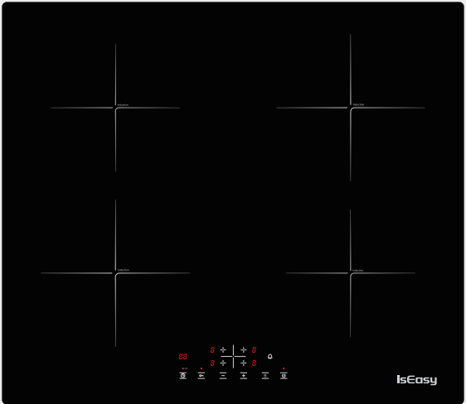

Specification of Induction Hob
Model Name : LI4-20
Product size : 590x520 mm
Built in size : 560x490 mm
Voltage : 220 - 240V , 50/60 Hz.
Power (total) : 6800W


English..............................................................................................................................................................................1-10
Deutsch ...........................................................................................................................................................................11-22
Français ............................................................................................................................................................................23-33
Español .............................................................................................................................................................................34-44
Italiano ...............................................................................................................................................................................45-54

CONTENTS

SAFTY INSTRUCTIONS............................................................................................................................................3
INSTALLATION...........................................................................................................................................................4
ELECTRICAL CONNECTION....................................................................................................................................5-6
BEFORE USE..................................................................................................................................................................7
INSTRUCTION FOR USE...........................................................................................................................................8
CLEANING.....................................................................................................................................................................9
TROUBLESHOOTING GUIDE...................................................................................................................................10
NOISES MADE BY THE HOB....................................................................................................................................10
AFTER-SALES SERVICE..............................................................................................................................................10

SAFETY INSTRUCTIONS
YOUR SAFETY AND THAT OF OTHERS IS VERY IMPORTANT
This manual and the appliance itself provide important safety messages, to be read and always observed.
This is the warning / caution-safety symbol, regarding safety, warning of potential risks to users and other


All messages relevant to safety specify the potential risk to which they refer and indicate how to reduce the risk ofinjury, damage and electric shocks due to incorrect use of the appliance. Make sure to comply with the following:
- The appliance must be disconnected from the power supply before carrying out any installation operation.
- Installation and maintenance must be carried out by a specialized technician, in compliance with themanufacturer’s instructions and the local safety regulations in force. Do not repair or replace any part of theappliance unless specifically stated in the user manual.
- The appliance must be earthed.
- The power cable must be long enough for connecting the appliance, fitted in the cabinet, to the power supply.
- For installation to comply with the current safety regulations, an omnipolar switch with minimum contact gapof 3mm is required.
- Do not use multi-sockets or extension cords.
- Do not pull the appliance’s power cable.
- The electrical parts must not be accessible to the user after installation.
- The appliance is designed solely for domestic use for cooking food. No other use is permitted (e.g. heatingrooms). The Manufacturer declines any liability for inappropriate use or incorrect setting of the controls.
- WARNING: The appliance and its accessible parts become hot during use. Care should be taken to avoid touchingheating elements. Children less than 8 years old shall be kept away unless continuously supervised.
- The accessible parts can become very hot during use. Children must be kept away from the appliance andwatched over to ensure they do not play with it.
- Do not touch the appliance heating elements during and after use. Do not allow the appliance to come intocontact with cloths or other flammable materials until all the components have cooled sufficiently.
- Do not place flammable materials on or near the appliance.
- Overheated oils and fats catch fire easily. Pay attention when cooking food products rich in fat and oil.
- This appliance can be used by children aged from 8 years and above and persons with reduced physical, sensoryor mental capabilities or lack of experience and knowledge if they have been given supervision or instructionconcerning use of the appliance in a safe way and understand hazards involved. Children shall not play with theappliance. Cleaning and user maintenance shall not be made by children without supervision.
- An air switch or circuit breaker (not supplied) should be installed in the compartment under the appliance.
- If the surface is cracked, switch off the appliance to avoid the possibility of electric shock.
- The appliance is not intended to be operated by means of an external timer or separate remote control system.
- WARNING: Unattended cooking on a hob with fat or oil can be dangerous and may result in fire. NEVER try toextinguish a fire with water, but switch off the appliance and then cover flame e.g. with a lid or a fire blanket.
- WARNING: Danger of fire: do not store items on the cooking surfaces.
- Do not use steam cleaners.
- Metallic objects such as knives, forks, spoons and lids should not be placed on the hob surface since they can get hot.
- After use, switch off the hob element by its control and do not rely on the pan detector.

INSTALLATION
After unpacking the product, check for any damage during transport. In case of problems, contact the dealer or the After-Sales Service.
For built-in dimensions and installation instruction, see inbelowfigures
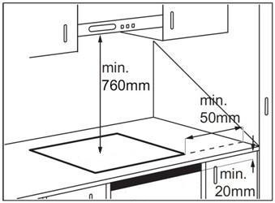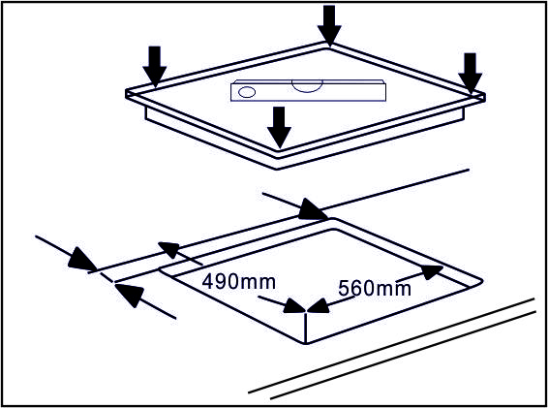
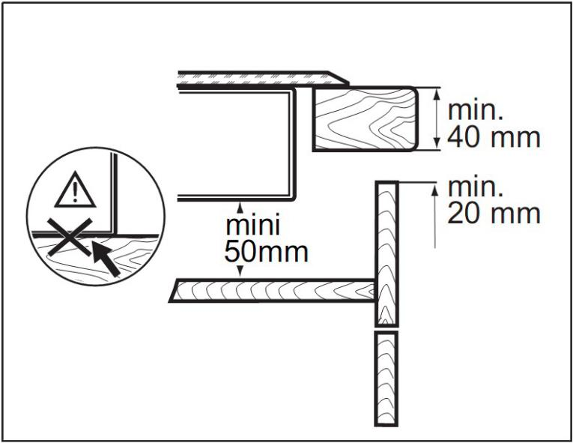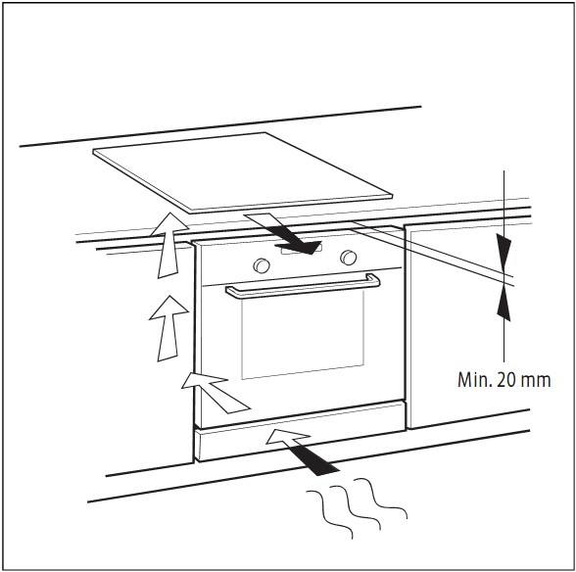
    - The distance between the underside of the appliance and the separator panel must respect the dimensions given in the figure (mini. 50mm).
- In order to ensure the correct operation of the product, do not obstruct the minimum required clearance(min. 20 mm) on the worktop for air flow out.
- If an undertop oven is installed, make sure the oven is equipped with a cooling system.
- Do not install the hob above a dishwasher or washing-machine, so that the electronic circuits do not come into contact with steam or moisture which could damage them.

ELECTRICAL CONNECTION
      - Disconnect the appliance from the power supply.
      - Installation must be carried out by qualified personnel who know the current safety andinstallation regulations.
- The manufacturer declines all liability for injury to persons or animals and for damage to property resulting from failure to observe the regulationsprovided in this chapter.
- The power cable must be long enough to allow the hob to be removed from the worktop.
- Make sure the voltage specified on the rating label located on the bottom of the appliance is the same as that of the home.
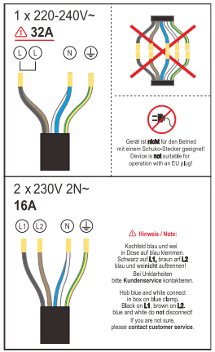
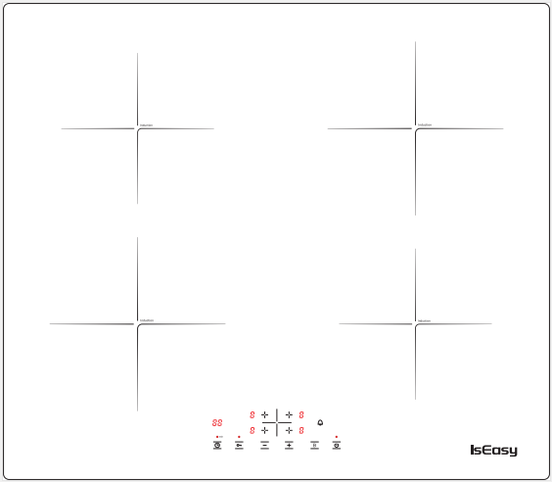

- Brown Fire Wire: power supply to the upper and lower plate on the left side.
- Black Fire Wire: power supply to the upper and lower plate on the right side.
- Control Board: Take 5V power from the lower right power board.
Regarding the wiring problem fault(please check which of the following is your hob problem):
- The upper and lower plate on the left side report "E8" or do not work at the same time. Check whether the brown fire wire is in poor contact. If the wiring is loose, please reconnect it. If you confirm that the wiring is normal, please contact us to send the pictures of the wiring location and a video of the hob failure.

- The upper and lower plates on the left and right sides, one of which reports E8, may be the power board is damaged. please contact us to send the pictures of the wiring location and a video of the hob failure.

Other related faults of the induction hob
- E1 Error: The wire reel is open circuit. (Motherboard problem.)
- E2 Error: The NTC of the wire reel stove surface probe is open circuit or short-circuited. (Main board problem, the stove surface probe NTC is not inserted into the black section, or the stove surface probe NTC is damaged.)

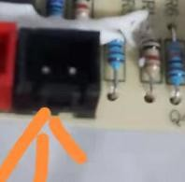
- E3 Error: high voltage failure. (First, make sure the voltage of your home circuit is 220V-240V. If the voltage is correct, there may be a problem with the motherboard.)
- E4 Error: low voltage failure. (First, make sure the voltage of your home circuit is 220V-240V. If the voltage is correct, there may be a problem with the motherboard.)
- E8 Error: communication failure. (The motherboard is damaged.)

Customer Service Email: service@iseasy.com
(Please send relevant videos and pictures to our email address, and attach your Amazon order number. After confirming the problem, we will definitely give you a satisfactory solution.)

BEFORE USE
IMPORTANT: The cooking zones will not switch on if pots are not the right size. Only use pots bearing the symbol “INDUCTION SYSTEM” (Figure below). Place the pot on the required cooking zone before switching the hob on.
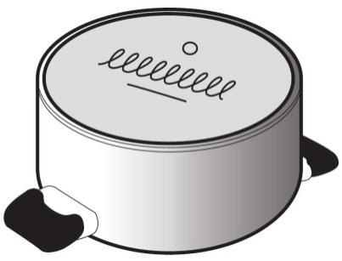

EXISTING POTS AND PANS
Use a magnet to check if the pot is suitable for the induction hob: pots and pans are unsuitable if not magnetically detectable.
- Make sure pots have a smooth bottom, otherwise they could scratch the hob. Check dishes.
- Never place hot pots or pans on the surface of the hob’s control panel. This could result in damage.
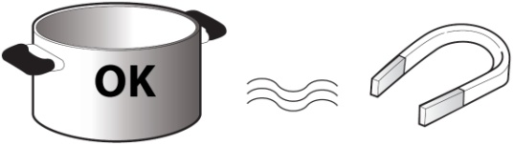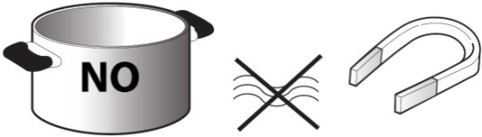
- The bottom diameter of pots or pans should be at least 10cm.

INSTRUCTION FOR USE
GENERAL OVERVIEW

To avoid permanently damaging the glass-ceramic top, do not use:
- Pots with bottoms that are not perfectly flat.
- Metal pots with enameled bottom.

CONTROL PANEL LAYOUT

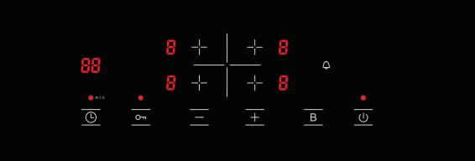

Switching the hob On/Off 
To switch the hob on, press the button and the cooking zone displays light up.

If within 120 seconds of switching on, no heating zone is selected, the hob switches off automatically.

Switching on and adjusting cooking level 
Once the hob is switched on and the pan is positioned on the chosen cooking zone, corresponding button: the display shows level 0.Each cooking zone has various power levels,adjust the power level by pressing the “+”or “-” key .

Booster function 
After select the cooking zone you wish, by pressing the B key to max level，The cooking area will continue to work in maximum gear for 5 minutes.

Child lock
This function locks the controls to prevent accidental switching on of the hob. To activate the child lock function， switch on the hob and hold button for three seconds; the timer shows Lo. Then the control panel is locked. To deactivate the control panel lock, repeat the activation procedure.The Lo goes off and the hob is active again.
Timer 
The timer can be used to set cooking time for a maximum of 99 minutes for all cooking zones.
Select the cooking zone to be used with the timer, press the button with the clock symbol then set the desired cooking time pressing  and ,After a few seconds, the timer begins the countdown.
Once the set time has elapsed, three acoustic signal sounds and the hob switch off automatically.
To deactivate the timer, hold the button with the clock symbol for at least 4 seconds.

Timer off bell

If you want to turn off the timing sound, please press this button. When the timing ends, no warning will be issued.

Auto switch off
The hob will automatically switch off when you did not set cooking time, forgot to switch off the hob, and did not operate the hob for two hours.

CONTROL PANEL WARNINGS
Residual heat indicator

- The hob is fitted with a residual heat indicator for each cooking zone.
- These indicators alert the user when cooking zones are still hot.
- If the display shows, the cooking zone is still hot.

- If the residual heat indicator of a given cooking zone is lit, that zone can be used, for example, to keep a dish warm or to melt butter.
- When the cooking zone cools down, the display goes off.

Incorrect or missing pot indicator
- If you are using a pot that is not suitable, not correctly positioned or not of the correct dimensions for your induction hob, the message “E0” will appear in the display, If no pot is detected within 120 seconds, the hob switches off.

CLEANING
    - Do not use steam cleaners.
    - Before cleaning, make sure the cooking zones are switched off and that the residual heat indicator (“H”) is not displayed.
IMPORTANT: Do not use abrasive sponges or scouring pads. Their use could eventually ruin the glass.
- After each use, clean the hob (when it is cool) to remove any deposits and stains due to food residuals.
- Sugar or foods with a high sugar content damage the hob and must be immediately removed.
- Salt, sugar and sand could scratch the glass surface.
- Use a soft cloth, absorbent kitchen paper or a specific hob cleaner (follow the Manufacturer’s instructions).

TROUBLESHOOTING GUIDE
- Read and follow the instructions given in the section “Instructions for use”.
- Check that the electricity supply has not been shut off.
- Dry the hob thoroughly after cleaning it.
- If, when the hob is switched on, alphanumeric codes appear on the display, consult the following table for instructions.
- If the hob cannot be switched off after using it, disconnect it from the power supply.

Error code | Possible Cause | Remedy
E0 | No Pan or did not detect the pan | Put on the pan
E2 | NTC short or open | Call the after-sales service and specify the error code
E3 | High voltage | Call the after-sales service and specify the error code
E4 | Low voltage | Call the after-sales service and specify the error code

NOISES MADE BY THE HOB
- Induction hobs can make whistling or crackling sounds during normal operation, these actually come from the pots and pans as a result of the characteristics of thebottoms (for example, bottoms made of several layers of material, or uneven bottoms).
- These noises vary depending on the pots and pans used and the amount of foodthey contain, and are not indicative of a defect of any kind.
- In addition, the induction hob is equipped with an internal cooling system to control the temperature of electronic parts; as a result, during operation and for severalminutes after the hob has been switched off, the noise of the cooling fan will be audible.
- This is perfectly normal and indeed essential for proper functioning of theappliance.

AFTER-SALES SERVICE
Before contacting the After-sales Service:
1. See if you can solve the problem yourself with the help of the “Troubleshooting guide”.
2. Switch the appliance off and then on again it to see if the problem has been eliminated.
If the problem persists after the above checks, contact the nearest After-Sales Service.
Always specify:
- a brief description of the fault
- the product type and exact model
- your full address
- your telephone number
If any repairs are required, contact an authorized After-Sales Service Centre(to ensure the use of original spare parts and correct repairs). Spare parts are available.

Energy saving
For optimum results, it is advisable to:
- Use pots and pans with bottom width equal to that of the cooking zone.
- Only use flat-bottomed pots and pans.
- When possible, keep pot lids on during cooking.
- Use a pressure cooker to save even more energy and time.
- Place the pot in the middle of the cooking zone marked on the hob.

Induktionskochfeld
Handbuch Anweisung
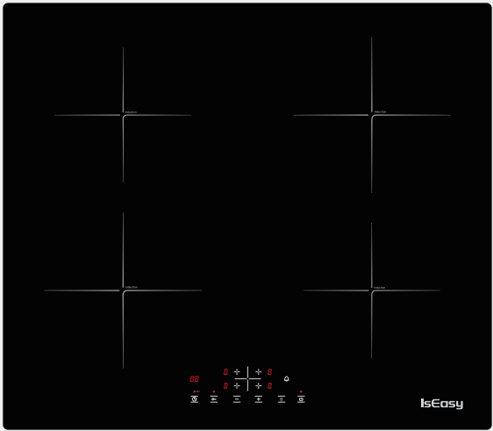

Spezifikation
Modellname : LI4-20
Produktgröße : 590x520 mm
Einbaugröße : 560x490 mm
Spannung : 220 - 240V , 50/60 Hz.
Leistung (gesamt) : 6800W

INHALT

SICHERHEITSHINWEISE............................................................................................................................13-14
INSTALLATION..............................................................................................................................................15
ELEKTRISCHER ANSCHLUSS.......................................................................................................................16-17
VOR DEM GEBRAUCH....................................................................................................................................18
ANLEITUNG ZUM GEBRAUCH......................................................................................................................19
TECHNISCHE INFORMATIONEN..................................................................................................................20
REINIGUNG...........................................................................................................................................................20
ANLEITUNG ZUR FEHLERSUCHE....................................................................................................................21
GERÄUSCHE DES KOCHFELDES......................................................................................................................21
KUNDENDIENST...................................................................................................................................................22

Sicherheitshinweise
IHRE SICHERHEIT UND DIE ANDERER IST SEHR WICHTIG

Dieses Handbuch und das gerät selbst enthalten wichtige sicherheitshinweise, die gelesen und immer beachtet werden müssen.
Dies ist das warn- / vorsichtssicherheitssymbol in bezug auf sicherheit, warnung vor potenziellen risiken für benutzer und andere.

Alle sicherheitsrelevanten meldungen geben das potenzielle risiko an, auf das sie sich beziehen, und geben an, wie das risiko von verletzungen, schäden und stromschlägen durch unsachgemäße verwendung des geräts verringert werden kann. stellen Sie sicher, dass folgendes eingehalten wird:
•1. Das gerät muss vor der installation von der stromversorgung getrennt werden.
•2. Installation und wartung müssen von einem spezialisierten techniker gemäß den anweisungen des herstellers und den geltenden örtlichen sicherheitsbestimmungen durchgeführt werden.Reparieren oder ersetzen sie keine teile des geräts, es sei denn, dies ist ausdrücklich in der bedienungsanleitung angegeben.
•3. Das gerät muss geerdet sein.
•4. Das netzkabel muss lang genug sein, um das im schrank installierte gerät an die stromversorgung anzuschließen.
•5. Für die installation gemäß den aktuellen sicherheitsbestimmungen ist ein omnipolarer schalter mit einem mindestkontaktabstand von 3 mm erforderlich.
•6. Verwenden sie keine mehrfachbuchsen oder verlängerungskabel.
•7. Ziehen sie nicht am netzkabel des geräts.
•8. Die elektrischen teile dürfen nach der installation für den benutzer nicht zugänglich sein.
•9. Das gerät ist ausschließlich für den hausgebrauch zum kochen von speisen vorgesehen. eine andere verwendung ist nicht gestattet (z. b. beheizung von räumen). Der hersteller lehnt jede haftung für unangemessene verwendung oder falsche einstellung der bedienelemente ab.
•10. Warnung: das gerät und seine zugänglichen teile werden während des gebrauchs heiß. Es ist darauf zu achten, dass die heizelemente nicht berührt werden. kinder unter 8 jahren sind fernzuhalten, sofern sie nicht ständig beaufsichtigt werden.
•11. Die zugänglichen teile können während des gebrauchs sehr heiß werden. Kinder müssen vom gerät ferngehalten und überwacht werden, um sicherzustellen, dass sie nicht damit spielen.
•12. Berühren sie die heizelemente des geräts während und nach dem gebrauch nicht. lassen sie das gerät nicht mit tüchern oder anderen brennbaren materialien in kontakt kommen, bis alle komponenten ausreichend abgekühlt sind.
•13. Legen sie keine brennbaren materialien auf oder in der nähe des geräts ab.
•14. Überhitzte öLe Und Fette EntzüNden Sich Leicht. Achten Sie Beim Kochen Von Fett- Und öLreichen Lebensmitteln Darauf.
•15. Dieses gerät kann von kindern ab 8 jahren und personen mit eingeschränkter körperlicher, sensorischer oder geistiger leistungsfähigkeit oder mangelnder erfahrung und wissen verwendet werden, wenn sie beaufsichtigt oder unterwiesen wurden, das gerät auf sichere weise zu verwenden und die gefahren zu verstehen beteiligt. Kinder dürfen nicht mit dem gerät spielen. reinigung und wartung durch den benutzer dürfen nicht von kindern ohne aufsicht durchgeführt werden.
•16. Ein luftschalter oder leistungsschalter (nicht mitgeliefert) sollte im fach unter dem gerät installiert werden.
•17. Wenn die oberfläche risse aufweist, schalten sie das gerät aus, um einen elektrischen schlag zu vermeiden.
•18. Das gerät darf nicht mit einem externen timer oder einer separaten fernbedienung betrieben werden.
•warnung: unbeaufsichtigtes kochen auf einem kochfeld mit fett oder öl kann gefährlich sein und zu einem brand führen. versuchen sie niemals, ein feuer mit wasser zu löschen, sondern schalten sie das gerät aus und decken sie dann die flamme ab, z. mit einem deckel oder einer feuerdecke.
•19. Warnung: brandgefahr: gegenstände nicht auf den kochflächen lagern.
•20. Verwenden sie keine dampfreiniger.
•21. Metallische gegenstände wie messer, gabeln, löffel und deckel sollten nicht auf die kochfeldoberfläche gestellt werden, da sie heiß werden können.
•22. Schalten sie das kochfeldelement nach dem gebrauch über die steuerung aus und verlassen sie sich nicht auf den pfannendetektor.

Installation
Überprüfen sie nach dem auspacken des produkts den transport auf beschädigungen. Bei problemen wenden sie sich an den händler oder den kundendienst.
Die eingebauten abmessungen und installationsanweisungen finden sie in den folgenden abbildungen.

      - Der abstand zwischen der unterseite des geräts und der trennwand muss die in der abbildung angegebenen maße einhalten (min. 50 mm).
      - Um den ordnungsgemäßen betrieb des produkts zu gewährleisten, darf der erforderliche mindestabstand (min. 20 mm) auf der arbeitsplatte für den luftaustritt nicht behindert werden.
      - Wenn ein unterbauofen installiert wird, stellen sie sicher, dass der ofen mit einem kühlsystem ausgestattet ist.
- Installieren sie das kochfeld nicht über einem geschirrspüler oder einer waschmaschine, damit die elektronischen schaltkreise nicht mit dampf oder feuchtigkeit in kontakt kommen, die sie beschädigen könnten.

Elektrische Verbindung
      - Trennen sie das gerät von der spannungsversorgung.
- Die installation muss von qualifiziertem personal durchgeführt werden, das die aktuellen sicherheits- und installationsvorschriften kennt.
- Der hersteller lehnt jede haftung für personen-, tier- und sachschäden ab, die sich aus der nichtbeachtung der in diesem kapitel vorgesehenen vorschriften ergeben.
- Das netzkabel muss so lang sein, dass das kochfeld von der arbeitsplatte abgenommen werden kann.
- Vergewissern sie sich, dass die auf dem typenschild an der unterseite des geräts angegebene spannung mit der spannung des hauses übereinstimmt.
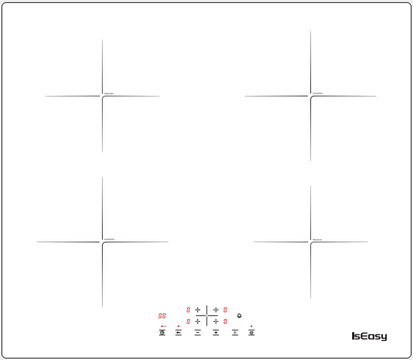

- Brauner Feuerdraht: Stromversorgung der oberen und unteren platte auf der linken seite.
- Schwarzer Feuerdraht: Stromversorgung der oberen und unteren platte auf der rechten seite.
- Steuerplatine: Nehmen sie 5V strom von der unteren rechten leistungsplatine.

Bezüglich des Verdrahtungsproblems (bitte überprüfen sie, welches der folgenden Probleme Ihr Kochfeld problem hat):

- Die obere und untere Platte auf der linken seite melden "E8" oder funktionieren nicht gleichzeitig. Prüfen Sie, ob der brauner feuerdraht schlechten Kontakt hat. Wenn die verkabelung locker ist, schließen sie sie bitte wieder an. Wenn Sie bestätigen, dass die verkabelung normal ist, kontaktieren sie uns bitte, um die bilder der verkabelungsposition und ein video des ausfalls des Kochfelds zu senden.

- Die obere und untere Platte links und einer der oberen und unteren Brenner rechts melden "E8". Die Leistungsplatine kann beschädigt und durchgebrannt sein. Bitte kontaktieren sie uns, um die bilder der verkabelungsposition und ein video des ausfalls des Kochfelds zu senden.

Andere verwandte Fehler des Induktionskochfelds:
- E1 Fehler: Die drahtspule ist offener Kreislauf. (Motherboard-Problem.)
- E2 Fehler: Der NTC des oberflächenfühlers des drahthaspelofens ist unterbrochen oder kurzgeschlossen. (Hauptplatinenproblem, ofenoberflächenfühler NTC ist nicht in den schwarzen abschnitt eingesteckt oder ofenoberflächenfühler NTC ist beschädigt.)

- E3 Fehler: Hochspannungsausfall. (Stellen Sie zunächst sicher, dass die spannung Ihres heimstromkreises 220 V-240 V beträgt. Wenn die spannung korrekt ist, kann ein problem mit dem motherboard vorliegen.)
- E4 Fehler: Niederspannungsausfall. (Stellen sie zunächst sicher, dass die spannung Ihres heimstromkreises 220 V-240 V beträgt. Wenn die spannung korrekt ist, kann ein problem mit dem motherboard vorliegen.)
- E8 Fehler: Kommunikationsfehler. (Das motherboard ist beschädigt.)

Kundenservice-E-Mail: service@iseasy.com
(Bitte senden sie relevante videos und bilder an unsere E-Mail-adresse und hängen sie Ihre Amazon-Bestellnummer an. Nach bestätigung des problems werden wir Ihnen auf jeden fall eine zufriedenstellende lösung anbieten.)

Vor Dem Gebrauch
WICHTIG: Die kochzonen schalten sich nicht ein, wenn die töpfe nicht die richtige größe haben. Verwenden Sie nur töpfe mit dem symbol “INDUCTION SYSTEM”(Abbildung unten). Stellen sie den topf auf die gewünschte kochzone, bevor sie das kochfeld einschalten.

Bestehende TöPfe Und Pfannen
Verwenden sie einen magneten, um zu prüfen, ob der topf für das Induktionskochfeld geeignet ist: töpfe und pfannen sind ungeeignet, wenn sie nicht magnetisch erkennbar sind.
- Stellen sie sicher, dass die töpfe einen glatten boden haben, da sie sonst das kochfeld zerkratzen können. Überprüfen sie das geschirr.
- Stellen sie niemals heiße töpfe oder pfannen auf die oberfläche des bedienfelds des kochfelds. Dies kann zu schäden führen.

- Der bodendurchmesser von töpfen oder pfannen sollte mindestens 10 cm betragen.

Anleitung zum Gebrauch
GesamtüBersicht


Verwenden sie folgendes nicht, um eine dauerhafte beschädigung der glaskeramikplatte zu vermeiden:
Töpfe mit nicht perfekt flachem boden.
Metalltöpfe mit emailliertem boden.

Bedienfeld-Layout

Kochfeld ein- / Ausschalten
Um das kochfeld einzuschalten, drücken sie die Taste und die kochzonenanzeigen leuchten auf.

Wenn innerhalb von 120 sekunden nach dem einschalten keine heizzone ausgewählt wird, schaltet sich das kochfeld automatisch aus.

Schalten das gerät ein und stellen die garstufe ein

Sobald das kochfeld eingeschaltet und die pfanne auf der gewählten kochzone positioniert ist, Entsprechende Taste: Das Display zeigt stufe 0 an. Jede Kochzone verfügt über verschiedene Leistungsstufen,Stellen sie die leistungsstufe ein, indem sie die Taste “+” oder “-” drücken .

Booster-Funktion

Nachdem sie die gewünschte kochzone ausgewählt haben, indem sie die taste B auf maximale stufe drücken, arbeitet die kochzone 5 minuten lang mit maximaler geschwindigkeit weiter.

Kindersicherung Schloss
Diese funktion verriegelt die bedienelemente, um ein versehentliches einschalten des kochfelds zu verhindern，Um die kindersicherung zu aktivieren, schalten sie das kochfeld ein und halten sie die taste kindersicherung drei sekunden lang gedrückt. Der timer zeigt Lo. Dann ist das bedienfeld gesperrt.
Um die bedienfeldsperre zu deaktivieren, wiederholen sie den aktivierungsvorgang. Der lo geht aus und das kochfeld ist wieder aktiv.

Timer

Mit dem timer kann die garzeit für alle kochzonen auf maximal 99 minuten eingestellt werden.

Wählen sie die kochzone aus, die mit dem timer verwendet werden soll, drücken Sie die taste mit dem uhrensymbol und stellen Sie die gewünschte garzeit ein, indem sie drücken und ,nach einigen sekunden startet der timer den countdown.
Nach ablauf der eingestellten zeit ertönen drei akustische signale und das kochfeld schaltet sich automatisch aus.
Halten sie zum deaktivieren des timers die taste mit dem uhrensymbol mindestens 4 sekunden lang gedrückt.

Timer-Aus-Glocke

Wenn sie den timing-ton ausschalten möchten, drücken sie bitte diese taste. Wenn die zeitmessung endet, wird keine warnung ausgegeben.

Automatisches Ausschalten
Wenn Sie keine kochzeit eingestellt, vergessen haben, das kochfeld auszuschalten, und das kochfeld zwei stunden lang nicht bedient haben, schaltet sich das kochfeld automatisch aus.

Warnhinweise für die bedienfeld
Restwärmeanzeige
- Das kochfeld ist mit einer restwärmeanzeige für jede kochzone ausgestattet.
- Diese anzeigen warnen den benutzer, wenn die kochzonen noch heiß sind.
- Wenn das display anzeigt , Die kochzone ist noch heiß.

- Wenn die restwärmeanzeige einer bestimmten kochzone leuchtet, kann diese zone beispielsweise dazu verwendet werden, ein gericht warm zu halten oder butter zu schmelzen.
- Wenn die kochzone abkühlt, erlischt die anzeige.

Falsche oder fehlende Topfanzeige
- Wenn sie einen topf verwenden, der für Ihr Induktionskochfeld nicht geeignet, nicht richtig positioniert oder nicht korrekt dimensioniert ist, wird im Display die Meldung “E0” angezeigt. Wenn innerhalb von 120 sekunden kein Topf erkannt wird, schaltet sich das kochfeld aus.

Technische Informationen
- Spannung: 220 - 240V 50/60 Hz
- Modellname: LI4-20
- Leistung: 6800W

Reinigung
Verwenden sie keine dampfreiniger.
Vergewissern sie sich vor der reinigung, dass die kochzonen ausgeschaltet sind und die restwärmeanzeige (“H”) nicht angezeigt wird.

WICHTIG: Verwenden sie keine schleifschwämme oder scheuerschwämme. ihre verwendung könnte schließlich das glas ruinieren.

- Reinigen sie das kochfeld nach jedem gebrauch (wenn es abgekühlt ist), um ablagerungen und flecken aufgrund von speiseresten zu entfernen.
- Zucker oder lebensmittel mit hohem zuckergehalt beschädigen das kochfeld und müssen sofort entfernt werden.
- Salz, zucker und sand können die glasoberfläche zerkratzen.
- Verwenden sie ein weiches tuch, saugfähiges küchenpapier oder einen speziellen kochfeldreiniger (befolgen sie die anweisungen des herstellers).

Anleitung zur Fehlersuche
- Lesen und befolgen Sie die Anweisungen im Abschnitt "Gebrauchsanweisung".
- Überprüfen Sie, ob die stromversorgung nicht unterbrochen wurde.
- Trocknen Sie das kochfeld nach dem reinigen gründlich ab.
- Wenn beim einschalten des kochfelds alphanumerische codes auf dem display angezeigt werden, finden sie anweisungen in der folgenden tabelle.
- Wenn das kochfeld nach dem gebrauch nicht ausgeschaltet werden kann, trennen sie es von der stromversorgung.
Fehlercode | Mögliche Ursache | Abhilfe
E0 | Keine Pfanne oder hat die Pfanne nicht erkannt | Setzen Sie die Pfanne auf
E2 | NTC short or open | Rufen sie den kundendienst an und geben sie den fehlercode an
E3 | Hochspannung | Rufen sie den kundendienst an und geben sie den fehlercode an
E4 | Niederspannung | Rufen sie den kundendienst an und geben sie den fehlercode an

GeräUsche des Kochfeldes
• Induktionskochfelder können während des normalen betriebs pfeifen oder knistern verursachen. Diese kommen aufgrund der eigenschaften des bodens (z. B. Boden aus mehreren Materialschichten oder unebener boden) tatsächlich aus den töpfen und pfannen.
• Diese geräusche variieren in abhängigkeit von den verwendeten töpfen und pfannen und der menge der darin enthaltenen lebensmittel und weisen nicht auf einen defekt jeglicher art hin.
• Zusätzlich ist das induktionskochfeld mit einem internen kühlsystem ausgestattet, um die temperatur elektronischer teile zu regeln. Infolgedessen ist während des betriebs und für einige minuten nach dem ausschalten des kochfelds das geräusch des lüfters hörbar.
• Dies ist völlig normal und für das ordnungsgemäße funktionieren des geräts unerlässlich.

Kundendienst

Bevor Sie sich an den Kundendienst wenden:
1. Prüfen sie, ob sie das problem mithilfe der "Anleitung zur Fehlerbehebung" selbst lösen können.
2. Schalten sie das gerät aus und wieder ein, um festzustellen, ob das problem behoben wurde.
Wenn das problem nach den oben genannten Überprüfungen weiterhin besteht, wenden sie sich an den nächstgelegenen kundendienst.
Geben Sie immer Folgendes an:
- Eine kurze beschreibung des Fehlers
- Produkttyp und genaues modell
- Ihre vollständige adresse
- Ihre telefonnummer
Wenn reparaturen erforderlich sind, wenden Sie sich an ein autorisiertes kundendienstzentrum (um die verwendung von originalersatzteilen und korrekte reparaturen sicherzustellen). Ersatzteile sind vorhanden.

Energie Sparen
Für optimale ergebnisse ist es ratsam:
- Verwenden sie töpfe und pfannen mit einer bodenbreite, die der der kochzone entspricht.
- Use verwenden sie nur töpfe und pfannen mit flachem boden.
- Wenn möglich, halten Sie die topfdeckel während des kochens auf.
- Verwenden sie einen schnellkochtopf, um noch mehr energie und zeit zu sparen.
- Stellen sie den topf in die mitte der auf dem kochfeld markierten kochzone.

IsEasy
PLAQUE À INDUCTION
Manuel d'instructions
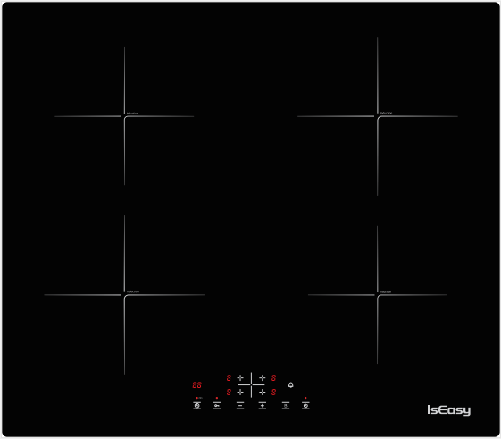

Spécification de la plaque à induction
Nom du modèle : LI4-20
Taille du produit : 590x520 mm
Taille intégrée : 560x490 mm
Tension : 220 - 240V , 50/60 Hz.
Puissance (totale) : 6800W

CONTENU

CONSIGNES DE SÉCURITÉ................................................................................................................................25
INSTALLATION......................................................................................................................................................26
CONNEXION ÉLECTRIQUE.................................................................................................................................27-28
AVANT UTILISATION............................................................................................................................................29
MODE D'EMPLOI....................................................................................................................................................30
NETTOYAGE...............................................................................................................................................................31
GUIDE DE DÉPANNAGE...........................................................................................................................................32
BRUITS FAITS PAR LE TRAVAIL.............................................................................................................................32
SERVICE APRÈS-VENTE.........................................................................................................................................33

CONSIGNES DE SÉCURITÉ
VOTRE SÉCURITÉ ET CELLE DES AUTRES EST TRÈS IMPORTANTE
Ce manuel et l'appareil lui-même fournissent des messages de sécurité importants, à lire et à toujours respecter.
Il s'agit du symbole d'avertissement / mise en garde-sécurité, concernant la sécurité, l'avertissement des risques potentiels pour les utilisateurs et d'autres

Tous les messages relatifs à la sécurité précisent le risque potentiel auquel ils se réfèrent et indiquent comment réduire le risque de blessures, dommages et chocs électriques dus à une utilisation incorrecte de l'appareil. Assurez-vous de respecter les points suivants:
- L'appareil doit être débranché de l'alimentation électrique avant d'effectuer toute opération d'installation.
- L'installation et l'entretien doivent être effectués par un technicien spécialisé, conformément aux instructions du fabricant et aux normes de sécurité locales en vigueur. Ne réparez ou ne remplacez aucune pièce de l'appareil, sauf indication contraire dans le manuel d'utilisation.
- L'appareil doit être mis à la terre.
- Le câble d'alimentation doit être suffisamment long pour raccorder l'appareil, monté dans l'armoire, à l'alimentation électrique.
- Pour que l'installation soit conforme aux réglementations de sécurité en vigueur, un interrupteur omnipolaire avec un écart de contact minimum de 3 mm est requis.
- N'utilisez pas de multiprises ni de rallonges.
- Ne tirez pas sur le câble d'alimentation de l'appareil.
- Les parties électriques ne doivent pas être accessibles à l'utilisateur après l'installation.
- L'appareil est conçu uniquement pour un usage domestique pour la cuisson des aliments. Aucune autre utilisation n'est autorisée (par ex. chaufferies). Le Fabricant décline toute responsabilité en cas d'utilisation inappropriée ou de réglage incorrect des commandes.
- AVERTISSEMENT : L'appareil et ses parties accessibles deviennent chauds pendant l'utilisation. Des précautions doivent être prises pour éviter de toucher les éléments chauffants. Les enfants de moins de 8 ans doivent être tenus à l'écart à moins d'être surveillés en permanence.
- Les parties accessibles peuvent devenir très chaudes pendant l'utilisation. Les enfants doivent être tenus à l'écart de l'appareil et surveillés pour s'assurer qu'ils ne jouent pas avec.
- Ne touchez pas les éléments chauffants de l'appareil pendant et après utilisation. Ne laissez pas l'appareil entrer en contact avec des chiffons ou d'autres matériaux inflammables tant que tous les composants n'ont pas suffisamment refroidi.
- Ne placez pas de matériaux inflammables sur ou à proximité de l'appareil.
- Les huiles et graisses surchauffées s'enflamment facilement. Faites attention lors de la cuisson de produits alimentaires riches en matières grasses et en huile.
- Cet appareil peut être utilisé par des enfants âgés de 8 ans et plus et des personnes ayant des capacités physiques, sensorielles ou mentales réduites ou un manque d'expérience et de connaissances s'ils ont reçu une supervision ou des instructions concernant l'utilisation de l'appareil en toute sécurité et comprennent les risques encourus. Les enfants ne doivent pas jouer avec l'appareil. Le nettoyage et l'entretien par l'utilisateur ne doivent pas être effectués par des enfants sans surveillance.
- Un interrupteur d'air ou un disjoncteur (non fourni) doit être installé dans le compartiment sous l'appareil.
- Si la surface est fissurée, éteignez l'appareil pour éviter tout risque d'électrocution.
- L'appareil n'est pas destiné à être utilisé au moyen d'une minuterie externe ou d'un système de télécommande séparé.
- AVERTISSEMENT : La cuisson sans surveillance sur une table de cuisson avec de la graisse ou de l'huile peut être dangereuse et provoquer un incendie. N'essayez JAMAIS d'éteindre un feu avec de l'eau, mais éteignez l'appareil puis couvrez la flamme, par ex. avec un couvercle ou une couverture anti-feu.
- AVERTISSEMENT : Danger d'incendie : ne stockez pas d'objets sur les surfaces de cuisson.
- N'utilisez pas de nettoyeurs à vapeur.
- Les objets métalliques tels que les couteaux, les fourchettes, les cuillères et les couvercles ne doivent pas être placés sur la surface de la table de cuisson car ils peuvent devenir chauds.
- Après utilisation, éteignez l'élément de cuisson par sa commande et ne vous fiez pas au détecteur de casserole.

INSTALLATION
Après avoir déballé le produit, vérifiez qu'il n'a pas été endommagé pendant le transport. En cas de problème, contactez le revendeur ou le service après-vente.
Pour les dimensions intégrées et les instructions d'installation, voir les figures ci-dessous
    - La distance entre le dessous de l'appareil et le panneau de séparation doit respecter les dimensions indiquées sur la figure (mini. 50 mm).
- Afin d'assurer le bon fonctionnement du produit, ne pas obstruer le dégagement minimum requis (min. 20 mm) sur le plan de travail pour la sortie d'air.
- Si un four encastré est installé, assurez-vous que le four est équipé d'un système de refroidissement.
- Ne pas installer la table de cuisson au-dessus d'un lave-vaisselle ou d'un lave-linge, afin que les circuits électroniques n'entrent pas en contact avec de la vapeur ou de l'humidité qui pourraient les endommager.

CONNEXION ÉLECTRIQUE
      - Débranchez l'appareil de l'alimentation électrique.
      - L'installation doit être effectuée par un personnel qualifié connaissant les normes de sécurité et d'installation en vigueur.

- Le fabricant décline toute responsabilité en cas de blessures aux personnes ou aux animaux et en cas de dommages matériels résultant du non-respect des prescriptions prévues dans ce chapitre.
- Le câble d'alimentation doit être suffisamment long pour permettre de retirer la table de cuisson du plan de travail.
- Assurez-vous que la tension spécifiée sur l'étiquette signalétique située au bas de l'appareil est la même que celle de la maison.

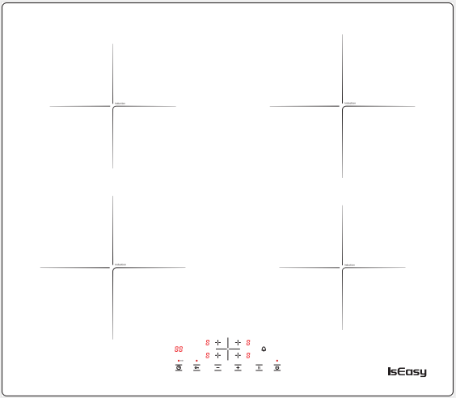

- Brown Fire Wire : alimentation des plaques supérieure et inférieure sur le côté gauche.
- Black Fire Wire : alimentation de la plaque supérieure et inférieure sur le côté droit.
- Tableau de commande : prenez l'alimentation 5 V de la carte d'alimentation en bas à droite.
En ce qui concerne le problème de câblage (veuillez vérifier lequel des éléments suivants est votre problème de table de cuisson):
- La plaque supérieure et inférieure sur le côté gauche signale "E8" ou ne fonctionne pas en même temps. Vérifiez si le fil de feu marron est en mauvais contact. Si le câblage est desserré, veuillez le reconnecter. Si vous confirmez que le câblage est normal, veuillez nous contacter pour envoyer les photos de l'emplacement du câblage et une vidéo de la panne de la table de cuisson.

- Les plaques supérieure et inférieure sur les côtés gauche et droit, dont l'une signale E8, peuvent être la carte d'alimentation endommagée. veuillez nous contacter pour envoyer les photos de l'emplacement du câblage et une vidéo de la panne de la table de cuisson.

Autres défauts liés de la plaque à induction
- Erreur E1 : La bobine de fil est en circuit ouvert. (Problème de carte mère.)
- Erreur E2 : Le NTC de la sonde de surface du poêle à enrouleur de fil est en circuit ouvert ou en court-circuit. (Problème de carte principale, la sonde de surface du poêle NTC n'est pas insérée dans la section noire ou la sonde de surface du poêle NTC est endommagée)

- Erreur E3 : panne de haute tension. (Tout d'abord, assurez-vous que la tension de votre circuit domestique est de 220 V-240 V. Si la tension est correcte, il peut y avoir un problème avec la carte mère.)
- Erreur E4 : panne de basse tension. (Tout d'abord, assurez-vous que la tension de votre circuit domestique est de 220 V-240 V. Si la tension est correcte, il peut y avoir un problème avec la carte mère.)
- Erreur E8 : échec de la communication. (La carte mère est endommagée.)

E-mail du service client : service@iseasy.com
(Veuillez envoyer des vidéos et des images pertinentes à notre adresse e-mail et joindre votre numéro de commande Amazon. Après confirmation du problème, nous vous donnerons certainement une solution satisfaisante.)

AVANT UTILISATION
IMPORTANT : Les zones de cuisson ne s'allumeront pas si les casseroles ne sont pas de la bonne taille. N'utilisez que des casseroles portant le symbole « SYSTÈME À INDUCTION » (Figure ci-dessous). Placez la casserole sur la zone de cuisson souhaitée avant d'allumer la table de cuisson.

CASSEROLES ET CASSEROLES EXISTANTES
Utilisez un aimant pour vérifier si la casserole est adaptée à la plaque à induction : les casseroles et les poêles ne conviennent pas si elles ne sont pas magnétiquement détectables.
- Assurez-vous que les casseroles ont un fond lisse, sinon elles pourraient rayer la table de cuisson. Vérifiez la vaisselle.
- Ne placez jamais de casseroles ou de poêles chaudes sur la surface du bandeau de commande de la table de cuisson. Cela pourrait entraîner des dommages.

- Le diamètre du fond des casseroles ou des poêles doit être d'au moins 10 cm.

MODE D'EMPLOI
APERÇU GÉNÉRAL

Pour éviter d'endommager définitivement le plateau en vitrocéramique, ne pas utiliser:
- Pots dont le fond n'est pas parfaitement plat.
- Pots en métal à fond émaillé.

DISPOSITION DU PANNEAU DE COMMANDE

Allumer/éteindre la table de cuisson
Pour allumer la table de cuisson, appuyez sur la touche et les affichages des zones de cuisson s'allument.

Si dans les 120 secondes suivant l'allumage, aucune zone de chauffe n'est sélectionnée, la table de cuisson s'éteint automatiquement.

Allumer et régler le niveau de cuisson
Une fois la table de cuisson allumée et la casserole positionnée sur le foyer choisi, touche correspondante : l'afficheur indique le niveau 0. Chaque foyer possède différents niveaux de puissance, réglez le niveau de puissance en appuyant sur la touche "+" ou "-" .

Fonction booster
Après avoir sélectionné la zone de cuisson que vous souhaitez, en appuyant sur la touche B au niveau maximum ， La zone de cuisson continuera à fonctionner à vitesse maximale pendant 5 minutes.

Sécurité enfant
Cette fonction verrouille les commandes pour éviter tout allumage accidentel de la table de cuisson. Pour activer la fonction de sécurité enfant, allumez la table de cuisson et maintenez le bouton "" enfoncé pendant trois secondes ; la minuterie indique Lo. Ensuite, le panneau de commande est verrouillé. Pour désactiver le verrouillage du panneau de commande, répétez la procédure d'activation. Le Lo s'éteint et la table de cuisson est à nouveau active.

Minuteur
La minuterie peut être utilisée pour régler le temps de cuisson sur un maximum de 99 minutes pour toutes les zones de cuisson.
Sélectionnez la zone de cuisson à utiliser avec la minuterie, appuyez sur le bouton avec le symbole de l'horloge puis réglez le temps de cuisson souhaité en appuyant sur "" et "",Après quelques secondes, la minuterie commence le compte à rebours.
Une fois le temps réglé écoulé, trois signaux sonores retentissent et la table de cuisson s'éteint automatiquement.
Pour désactiver la minuterie, maintenez le bouton avec le symbole de l'horloge enfoncé pendant au moins 4 secondes.

Minuterie d'arrêt

Si vous souhaitez désactiver le son de synchronisation, veuillez appuyer sur ce bouton. À la fin du chronométrage, aucun avertissement ne sera émis.

Arrêt automatique
La table de cuisson s'éteint automatiquement lorsque vous n'avez pas réglé le temps de cuisson, avez oublié d'éteindre la table de cuisson et n'avez pas fait fonctionner la table de cuisson pendant deux heures.

AVERTISSEMENTS DU PANNEAU DE COMMANDE
Indicateur de chaleur résiduelle
- La table de cuisson est équipée d'un indicateur de chaleur résiduelle pour chaque zone de cuisson.
- Ces indicateurs alertent l'utilisateur lorsque les zones de cuisson sont encore chaudes.
- Si l'affichage indique, la zone de cuisson est encore chaude.

- Si le voyant de chaleur résiduelle d'une zone de cuisson donnée est allumé, cette zone peut être utilisée, par exemple, pour maintenir un plat au chaud ou pour faire fondre du beurre.
- Lorsque la zone de cuisson refroidit, l'affichage s'éteint.

Indicateur de pot incorrect ou manquant
- Si vous utilisez une casserole qui ne convient pas, n'est pas correctement positionnée ou n'a pas les bonnes dimensions pour votre plaque à induction, le message "E0" apparaît à l'écran, Si aucune casserole n'est détectée dans les 120 secondes, la plaque s'éteint.

NETTOYAGE
    - Ne pas utiliser de nettoyeurs à vapeur.
    - Avant le nettoyage, assurez-vous que les zones de cuisson sont éteintes et que l'indicateur de chaleur résiduelle ("H") n'est pas affiché.
IMPORTANT : N'utilisez pas d'éponges abrasives ni de tampons à récurer. Leur utilisation pourrait éventuellement ruiner le verre.
- Après chaque utilisation, nettoyez la table de cuisson (lorsqu'elle est froide) pour éliminer les éventuels dépôts et taches dus aux résidus alimentaires.
- Le sucre ou les aliments à forte teneur en sucre endommagent la table de cuisson et doivent être immédiatement retirés.
- Le sel, le sucre et le sable pourraient rayer la surface du verre.
- Utilisez un chiffon doux, du papier essuie-tout absorbant ou un nettoyant spécifique pour plaques de cuisson (suivre les instructions du fabricant).

GUIDE DE DÉPANNAGE
- Lisez et suivez les instructions données dans la section "Instructions d'utilisation".
- Vérifiez que l'alimentation électrique n'a pas été coupée.
- Séchez soigneusement la table de cuisson après l'avoir nettoyée.
- Si, lorsque la table de cuisson est allumée, des codes alphanumériques s'affichent à l'écran, consultez le tableau suivant pour les instructions.
- Si la table de cuisson ne peut pas être éteinte après l'avoir utilisée, débranchez-la de l'alimentation électrique.

Code d'erreur | Cause possible | Remède
E0 | Pas de panoramique ou pas de détection de panoramique | Mettre sur la casserole
E2 | NTC court ou ouvert | Appeler le SAV et préciser le code erreur
E3 | Haute tension | Appeler le SAV et préciser le code erreur
E4 | Basse tension | Appeler le SAV et préciser le code erreur

BRUITS FAITS PAR LA TABLE DE CUISSON
- Les plaques à induction peuvent émettre des sifflements ou des crépitements en fonctionnement normal, ceux-ci proviennent en fait des casseroles et poêles en raison des caractéristiques des fonds (par exemple, fonds constitués de plusieurs couches de matériau, ou fonds irréguliers).
- Ces bruits varient selon les casseroles et poêles utilisées et la quantité d'aliments qu'elles contiennent, et ne sont pas révélateurs d'un défaut de quelque nature que ce soit.
- De plus, la plaque à induction est équipée d'un système de refroidissement interne pour contrôler la température des composants électroniques ; par conséquent, pendant le fonctionnement et pendant plusieurs minutes après l'extinction de la table de cuisson, le bruit du ventilateur de refroidissement sera audible.
- Ceci est parfaitement normal et même indispensable au bon fonctionnement de l'appareil.

SERVICE APRÈS-VENTE
Avant de contacter le SAV:
1. Voyez si vous pouvez résoudre le problème vous-même à l'aide du « Guide de dépannage ».
2. Éteignez l'appareil puis rallumez-le pour voir si le problème a été résolu.
Si le problème persiste après les vérifications ci-dessus, contactez le Service Après-Vente le plus proche.

Précisez toujours:
- une brève description de la panne
- le type de produit et le modèle exact
- votre adresse complète
- Ton numéro de téléphone

Si des réparations sont nécessaires, contactez un centre de service après-vente agréé (pour garantir l'utilisation de pièces de rechange d'origine et des réparations correctes). Les pièces de rechange sont disponibles

Économie d'énergie
Pour un résultat optimal, il est conseillé de:
- Utilisez des casseroles et des poêles dont la largeur du fond est égale à celle de la zone de cuisson.
- N'utilisez que des casseroles et des poêles à fond plat.
- Dans la mesure du possible, gardez les couvercles des casseroles pendant la cuisson.
- Utilisez un autocuiseur pour économiser encore plus d'énergie et de temps.
- Placez la casserole au milieu de la zone de cuisson marquée sur la table de cuisson.

PLACA DE INDUCCIÓN
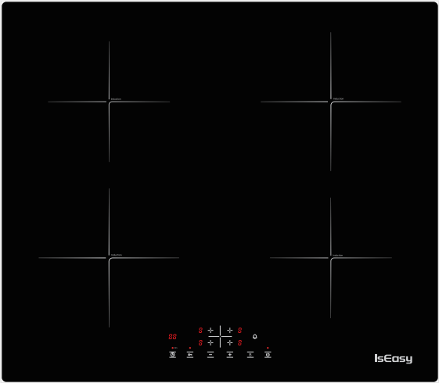
Manual de instrucciones

Especificación de la placa de inducción
Nombre del modelo : LI4-20
Tamaño del producto : 590x520 mm
Tamaño incorporado : 560x490 mm
Voltaje : 220 - 240V , 50/60 Hz.
Energía (total) : 6800W

CONTENIDO

INSTRUCCIONES DE SEGURIDAD.................................................................................................................36
INSTALACIÓN.......................................................................................................................................................37
CONEXIÓN ELÉCTRICA.......................................................................................................................................38-39
ANTES DE USAR.....................................................................................................................................................40
INSTRUCCIONES DE USO...................................................................................................................................41-42
LIMPIEZA....................................................................................................................................................................42
GUÍA PARA RESOLVER PROBLEMAS.................................................................................................................43
RUIDO DE LA ENCIMERA........................................................................................................................................44
SERVICIO POSTVENTA.......................................................................................................................................................44

INSTRUCCIONES DE SEGURIDAD
SU SEGURIDAD Y LA DE OTROS ES MUY IMPORTANTE
Este manual y el propio aparato proporcionan importantes mensajes de seguridad, que deben leerse y observarse siempre.
Este es el símbolo de advertencia/precaución-seguridad, con respecto a la seguridad, advertencia de riesgos potenciales para los usuarios y otros

Todos los mensajes relacionados con la seguridad especifican el riesgo potencial al que se refieren e indican cómo reducir el riesgo de lesiones, daños y descargas eléctricas debido al uso incorrecto del aparato. Asegúrese de cumplir con lo siguiente:
- El aparato debe estar desconectado de la red eléctrica antes de realizar cualquier operación de instalación.
- La instalación y el mantenimiento deben ser realizados por un técnico especializado, respetando las instrucciones del fabricante y las normas de seguridad locales vigentes. No repare ni reemplace ninguna pieza del aparato a menos que se indique específicamente en el manual del usuario.
- El aparato debe estar conectado a tierra.
- El cable de alimentación debe tener la longitud suficiente para conectar el aparato, instalado en el armario, a la red eléctrica.
- Para que la instalación cumpla con las normas de seguridad vigentes, se requiere un interruptor omnipolar con distancia mínima entre contactos de 3 mm.
- No utilice enchufes múltiples o cables de extensión.
- No tire del cable de alimentación del aparato.
- Las partes eléctricas no deben ser accesibles al usuario después de la instalación.
- El aparato está diseñado únicamente para uso doméstico para cocinar alimentos. otro uso no es permitido(p.ej. cuartos de calefacción). El Fabricante declina cualquier responsabilidad por el uso inadecuado o la configuración incorrecta de los controles.
- ADVERTENCIA: El aparato y sus partes accesibles se calientan durante el uso. Se debe tener cuidado para evitar tocar los elementos calefactores. Los niños menores de 8 años deben mantenerse alejados a menos que estén supervisados continuamente.
- Las partes accesibles pueden calentarse mucho durante el uso. Los niños deben mantenerse alejados del aparato y vigilarse para asegurarse de que no jueguen con él.
- No toque los elementos calefactores del aparato durante y después del uso. No permita que el aparato entre en contacto con paños u otros materiales inflamables hasta que todos los componentes se hayan enfriado lo suficiente.
- No coloque materiales inflamables sobre o cerca del aparato.
- Los aceites y grasas sobrecalentados se incendian fácilmente. Preste atención al cocinar productos alimenticios ricos en grasa y aceite.
- Este aparato puede ser utilizado por niños a partir de 8 años y personas con capacidades físicas, sensoriales o mentales reducidas o falta de experiencia y conocimiento si han recibido supervisión o instrucciones sobre el uso del aparato de forma segura y comprenden los peligros involucrados. Los niños no deben jugar con el aparato. La limpieza y el mantenimiento del usuario no deben ser realizados por niños sin supervisión.
- Se debe instalar un interruptor de aire o disyuntor (no incluido) en el compartimiento debajo del aparato.
- Si la superficie está agrietada, apague el aparato para evitar la posibilidad de descarga eléctrica.
- El aparato no está diseñado para ser operado por medio de un temporizador externo o un sistema de control remoto separado.
- ADVERTENCIA: Cocinar sin supervisión en una placa con grasa o aceite puede ser peligroso y puede provocar un incendio. NUNCA intente apagar un fuego con agua, apague el aparato y luego cubra la llama, p. con tapa o manta ignífuga.
- ADVERTENCIA: Peligro de incendio: no guarde artículos sobre las superficies de cocción.
- No use limpiadores de vapor.
- No se deben colocar objetos metálicos como cuchillos, tenedores, cucharas y tapas sobre la superficie de la placa, ya que pueden calentarse.
- Después del uso, apague la placa de cocción con su control y no confíe en el detector de sartenes.

INSTALLATION
Después de desembalar el producto, compruebe si ha sufrido daños durante el transporte. En caso de problemas, póngase en contacto con el distribuidor o el Servicio Postventa.
Para conocer las dimensiones integradas y las instrucciones de instalación, consulte las siguientes figuras
    - La distancia entre la parte inferior del aparato y el panel separador debe respetar las dimensiones indicadas en la figura (mín. 50 mm).
- Para garantizar el correcto funcionamiento del producto, no obstruya el espacio libre mínimo requerido (mín. 20 mm) en la encimera para que salga el aire
- Si se instala un horno bajo encimera, asegúrese de que el horno esté equipado con un sistema de enfriamiento.
- No instale la placa encima de un lavavajillas o lavadora, para que los circuitos electrónicos no entren en contacto con el vapor o la humedad que podrían dañarlos.

CONEXIÓN ELÉCTRICA
      - Desconecte el aparato de la fuente de alimentación.
      - La instalación debe ser realizada por personal cualificado que conozca las normas de seguridad e instalación vigentes.
- El fabricante declina toda responsabilidad por lesiones a personas o animales y por daños a la propiedad resultantes del incumplimiento de las normas previstas en este capítulo.
- El cable de alimentación debe tener la longitud suficiente para permitir retirar la placa de la encimera.
- Asegúrese de que el voltaje especificado en la etiqueta de clasificación ubicada en la parte inferior del electrodoméstico sea el mismo que el de la casa.

- Alambre de fuego marrón: fuente de alimentación a la placa superior e inferior en el lado izquierdo.
- Alambre de fuego negro: fuente de alimentación a la placa superior e inferior en el lado derecho.
- Tablero de control: tome 5V de energía del tablero de alimentación inferior derecho.
Con respecto a la falla del problema de cableado(por favor, compruebe cuál de los siguientes es su problema de placa):
- La placa superior e inferior del lado izquierdo informan "E8" o no funcionan al mismo tiempo. Compruebe si el cable de fuego marrón está en mal contacto. Si el cableado está suelto, vuelva a conectarlo. Si confirma que el cableado es normal, contáctenos para enviarle las imágenes de la ubicación del cableado y un video de la falla de la placa.

- Las placas superior e inferior en los lados izquierdo y derecho, una de las cuales informa E8, puede ser que la placa de alimentación esté dañada. Póngase en contacto con nosotros para enviar las imágenes de la ubicación del cableado y un video de la falla de la placa.

Otros fallos relacionados de la placa de inducción
- E1 Error: El carrete de alambre está en circuito abierto. (Problema de la placa base.)
- E2 Error: El NTC de la sonda de superficie de la estufa de bobina está en circuito abierto o en cortocircuito. (Problema de la placa principal, la sonda de superficie de la estufa NTC no está insertada en la sección negra o la sonda de superficie de la estufa NTC está dañada.)

- E3 Error: falla de alto voltaje. (Primero, asegúrese de que el voltaje de su circuito doméstico sea de 220V-240V. Si el voltaje es correcto, puede haber un problema con la placa base.)
- E4 Error: falla de bajo voltaje. (Primero, asegúrese de que el voltaje de su circuito doméstico sea de 220V-240V. Si el voltaje es correcto, puede haber un problema con la placa base.)
- E8 Error: fallo de comunicación. (La placa base está dañada.)

Correo electrónico de atención al cliente:service@iseasy.com
(Envíe videos e imágenes relevantes a nuestra dirección de correo electrónico y adjunte su número de pedido de Amazon. Después de confirmar el problema, definitivamente le daremos una solución satisfactoria.)

ANTES DE USAR
IMPORTANTE: Las zonas de cocción no se encenderán si las ollas no son del tamaño adecuado. Utilice únicamente recipientes que lleven el símbolo “SISTEMA DE INDUCCIÓN” (Figura siguiente). Coloque la olla en la zona de cocción deseada antes de encender la placa.

OLLAS Y SARTENES EXISTENTES
Utilice un imán para comprobar si la olla es adecuada para la placa de inducción: las ollas y sartenes no son adecuadas si no se detectan magnéticamente.
- Asegúrate de que las ollas tengan el fondo liso, de lo contrario podrían rayar la placa. Consultar platos.
- Nunca coloque ollas o sartenes calientes sobre la superficie del panel de control de la placa. Esto podría resultar en daños.
- El diámetro inferior de las ollas o sartenes debe ser de al menos 10 cm.

INSTRUCCIONES DE USO
VISIÓN GENERAL

Para evitar daños permanentes en la superficie de vitrocerámica, no utilice:
- Macetas con fondos que no son perfectamente planos.
- Macetas de metal con fondo esmaltado.

DISPOSICIÓN DEL PANEL DE CONTROL

Encendido/apagado de la placa
Para encender la placa, pulse el botón el botón y las indicaciones de las zonas de cocción se iluminan.

Si dentro de los 120 segundos posteriores al encendido, no se selecciona ninguna zona de calentamiento, la placa se apaga automáticamente.

Encendido y ajuste del nivel de cocción
Una vez que se enciende la placa y se coloca la olla en la zona de cocción elegida, botón correspondiente: la pantalla muestra el nivel 0. Cada zona de cocción tiene varios niveles de potencia, ajuste el nivel de potencia presionando la tecla "+" o "-" .

función de refuerzo
Después de seleccionar la zona de cocción que desee, presione la tecla B hasta el nivel máximo, El área de cocción seguirá funcionando al máximo durante 5 minutos.

Bloqueo para niños
Esta función bloquea los controles para evitar el encendido accidental de la placa. Para activar la función de bloqueo para niños， encienda la placa y mantenga presionado el botón durante tres segundos; el temporizador muestra Lo. Entonces el panel de control está bloqueado. Para desactivar el bloqueo del panel de control, repita el procedimiento de activación. El Lo se apaga y la placa vuelve a estar activa.
Temporizador
El temporizador se puede usar para configurar el tiempo de cocción para un máximo de 99 minutos para todas las zonas de cocción.
Seleccione la zona de cocción a utilizar con el temporizador, presione el botón con el símbolo del reloj y luego configure el tiempo de cocción deseado presionando y ,Después de unos segundos, el temporizador comienza la cuenta regresiva.
Una vez transcurrido el tiempo establecido, suenan tres señales acústicas y la placa se apaga automáticamente.
Para desactivar el temporizador, mantenga presionado el botón con el símbolo del reloj durante al menos 4 segundos.

Temporizador de campana

Si desea desactivar el sonido de temporización, presione este botón. Cuando termine el tiempo, no se emitirá ninguna advertencia.

Apagado automático
La placa se apagará automáticamente cuando no configuró el tiempo de cocción, olvidó apagar la placa y no operó la placa durante dos horas.

ADVERTENCIAS DEL PANEL DE CONTROL
Indicador de calor residual
- La placa está equipada con un indicador de calor residual para cada zona de cocción.
- Estos indicadores alertan al usuario cuando las zonas de cocción todavía están calientes.
- Si la pantalla muestra , la zona de cocción todavía está caliente.

- Si el indicador de calor residual de una zona de cocción determinada está encendido, esa zona se puede utilizar, por ejemplo, para mantener un plato caliente o para derretir mantequilla.
- Cuando la zona de cocción se enfría, la pantalla se apaga.

Indicador de bote incorrecto o faltante
- Si está utilizando una olla que no es adecuada, no está correctamente colocada o no tiene las dimensiones correctas para su placa de inducción, aparecerá el mensaje "E0" en la pantalla. Si no se detecta ninguna olla en 120 segundos, la placa se apaga.

LIMPIEZA
    - No use limpiadores de vapor.
    - Antes de limpiar, asegúrese de que las zonas de cocción estén apagadas y que el indicador de calor residual ("H") no se muestre.
IMPORTANTE: No utilice esponjas abrasivas ni estropajos. Su uso eventualmente podría arruinar el vidrio.
- Después de cada uso, limpiar la placa (cuando esté fría) para eliminar los depósitos y manchas de restos de comida.
- El azúcar o los alimentos con un alto contenido de azúcar dañan la placa y deben retirarse inmediatamente.
- La sal, el azúcar y la arena podrían rayar la superficie del vidrio.
- Utilizar un paño suave, papel de cocina absorbente o un limpiador de vitrocerámicas específico (siga las instrucciones del fabricante).

GUÍA PARA RESOLVER PROBLEMAS
- Lea y siga las instrucciones dadas en la sección “Instrucciones de uso”.
- Comprobar que no se ha cortado el suministro eléctrico.
- Seque bien la placa después de limpiarla.
- Si al encender la placa aparecen códigos alfanuméricos en la pantalla, consulte la siguiente tabla para obtener instrucciones.
- Si la placa no se puede apagar después de usarla, desconéctela de la fuente de alimentación.

Error código | Causa posible | Recurso
E0 | No Pan o no detectó el pan | poner en la sartén
E2 | NTC corto o abierto | Llame al servicio postventa y especifique el código de error
E3 | Alto voltaje | Llame al servicio postventa y especifique el código de error
E4 | Baja tensión | Llame al servicio postventa y especifique el código de error

RUIDO DE LA ENCIMERA
- Las placas de inducción pueden emitir silbidos o crujidos durante el funcionamiento normal, estos en realidad provienen de las ollas y sartenes como resultado de las características de los fondos (por ejemplo, fondos hechos de varias capas de material o fondos irregulares).
- Estos ruidos varían en función de las ollas y sartenes utilizadas y de la cantidad de alimentos que contengan, y no son indicativos de defecto de ningún tipo.
- Además, la placa de inducción está equipada con un sistema de refrigeración interno para controlar la temperatura de los componentes electrónicos; como resultado, durante el funcionamiento y durante varios minutos después de que la placa se haya apagado, el ruido del ventilador de enfriamiento será audible.
- Esto es perfectamente normal y, de hecho, esencial para el correcto funcionamiento del aparato.

SERVICIO POSTVENTA
Antes de contactar con el Servicio Postventa:
1. Vea si puede resolver el problema usted mismo con la ayuda del “Guía para resolver problemas”.
2. Apague el aparato y vuelva a encenderlo para ver si el problema se ha solucionado.
Si el problema persiste después de las comprobaciones anteriores, póngase en contacto con el Servicio Postventa más cercano.
Siempre especifica:
- una breve descripción de la falla
- el tipo de producto y el modelo exacto
- tu dirección completa
- tu numero de telefono
Si es necesaria alguna reparación, contacte con un Centro de Servicio Postventa autorizado (para garantizar el uso de repuestos originales y la reparación correcta). Las piezas de repuesto están disponibles.

El ahorro de energía
Para obtener resultados óptimos, es recomendable:
- Use ollas y sartenes con un ancho de fondo igual al de la zona de cocción.
- Utilice únicamente ollas y sartenes de fondo plano.
- Cuando sea posible, mantenga las tapas de las ollas puestas durante la cocción.
- Use una olla a presión para ahorrar aún más energía y tiempo.
- Coloque la olla en el centro de la zona de cocción marcada en la encimera.

PIANO A INDUZIONE
Manuale di istruzioni
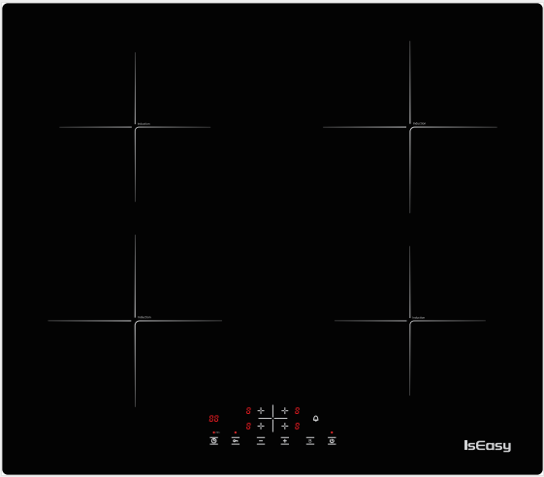

Specifiche del piano cottura a induzione
Nome del modello : LI4-20
Taglia del prodotto : 590x520 mm
Dimensioni costruite : 560x490 mm
Voltaggio : 220 - 240V , 50/60 Hz.
Potenza (totale) : 6800W

CONTENUTI

ISTRUZIONI DI SICUREZZA............................................................................................................................47
INSTALLAZIONE.................................................................................................................................................48
CONNESSIONE ELETTRICA..............................................................................................................................49-50
PRIMA DELL'USO.................................................................................................................................................50
ISTRUZIONI PER L'USO......................................................................................................................................51-52
PULIZIA....................................................................................................................................................................52
GUIDA ALLA RISOLUZIONE DEI PROBLEMI..................................................................................................53
RUMORI PRODOTTI DAL PIANO COTTURA..................................................................................................53
ASSISTENZA POST-VENDITA..............................................................................................................................54

ISTRUZIONI DI SICUREZZA
LA TUA SICUREZZA E QUELLA DEGLI ALTRI È MOLTO IMPORTANTE
Questo manuale e l'apparecchio stesso forniscono importanti messaggi di sicurezza, da leggere e sempre osservare.
Questo è il simbolo di avvertenza/precauzione-sicurezza, relativo alla sicurezza, avvertenza di potenziali rischi per gli utenti e altro

Tutti i messaggi relativi alla sicurezza specificano il potenziale rischio a cui si riferiscono e indicano come ridurre il rischio di lesioni, danni e scosse elettriche dovute a un uso non corretto dell'apparecchio. Assicurati di rispettare quanto segue:
- L'apparecchio deve essere scollegato dalla rete elettrica prima di eseguire qualsiasi operazione di installazione.
- L'installazione e la manutenzione devono essere eseguite da un tecnico specializzato, nel rispetto delle istruzioni del costruttore e delle vigenti norme di sicurezza locali. Non riparare o sostituire alcuna parte dell'apparecchio se non espressamente indicato nel manuale utente.
- L'apparecchio deve essere collegato a terra.
- Il cavo di alimentazione deve essere sufficientemente lungo per collegare l'apparecchio, montato nel mobile, alla rete elettrica.
- Per un'installazione conforme alle vigenti norme di sicurezza è necessario un interruttore onnipolare con distanza minima di contatto di 3 mm.
- Non utilizzare prese multiple o prolunghe.
- Non tirare il cavo di alimentazione dell'apparecchio.
- Le parti elettriche non devono essere accessibili all'utente dopo l'installazione.
- L'apparecchio è destinato esclusivamente all'uso domestico per la cottura di cibi. Non è consentito nessun altro uso (es. locali di riscaldamento). Il Costruttore declina ogni responsabilità per uso improprio o errata impostazione dei comandi.
- AVVERTENZA: L'apparecchio e le sue parti accessibili si scaldano durante l'uso. Prestare attenzione per evitare di toccare gli elementi riscaldanti. I bambini di età inferiore a 8 anni devono essere tenuti lontani a meno che non siano costantemente sorvegliati.
- Le parti accessibili possono diventare molto calde durante l'uso. I bambini devono essere tenuti lontani dall'apparecchio e sorvegliati per assicurarsi che non ci giochino.
- Non toccare le resistenze dell'apparecchio durante e dopo l'uso. Non permettere all'apparecchio di entrare in contatto con panni o altri materiali infiammabili finché tutti i componenti non si sono sufficientemente raffreddati.
- Non posizionare materiali infiammabili sopra o vicino all'apparecchio.
- Oli e grassi surriscaldati prendono fuoco facilmente. Prestare attenzione durante la cottura di alimenti ricchi di grassi e olio.
- Questo apparecchio può essere utilizzato da bambini di età pari o superiore a 8 anni e da persone con ridotte capacità fisiche, sensoriali o mentali o prive di esperienza e conoscenza se sono state seguite o istruite sull'uso dell'apparecchio in modo sicuro e se hanno compreso i rischi connessi. I bambini non devono giocare con l'apparecchio. La pulizia e la manutenzione da parte dell'utente non devono essere effettuate da bambini senza supervisione.
- Nel vano sotto l'apparecchio deve essere installato un interruttore dell'aria o un interruttore automatico (non in dotazione).
- Se la superficie è incrinata, spegnere l'apparecchio per evitare la possibilità di scosse elettriche.
- L'apparecchio non è progettato per essere azionato tramite un timer esterno o un sistema di controllo remoto separato.
- AVVERTENZA: La cottura incustodita su un piano cottura con grasso o olio può essere pericolosa e provocare incendi. NON tentare MAI di spegnere un incendio con acqua, ma spegnere l'apparecchio e poi coprire la fiamma, ad es. con un coperchio o una coperta antincendio.
- ATTENZIONE: Pericolo di incendio: non riporre oggetti sui piani di cottura.
- Non utilizzare pulitori a vapore.
- Gli oggetti metallici come coltelli, forchette, cucchiai e coperchi non devono essere appoggiati sulla superficie del piano di cottura poiché possono surriscaldarsi.
- Dopo l'uso, spegnere l'elemento del piano di cottura tramite il suo comando e non fare affidamento sul rilevatore di pentole.

INSTALLAZIONE
Dopo aver disimballato il prodotto, verificare la presenza di eventuali danni durante il trasporto. In caso di problemi, contattare il rivenditore o il Servizio Post Vendita.
Per le dimensioni integrate e le istruzioni di installazione, vedere le figure seguenti
    - La distanza tra la parte inferiore dell'apparecchio e il pannello separatore deve rispettare le dimensioni indicate in figura (mini. 50mm).
- Per garantire il corretto funzionamento del prodotto, non ostruire lo spazio minimo richiesto (min. 20 mm) sul piano di lavoro per il deflusso dell'aria.
- Se è installato un forno sottopiano, assicurarsi che il forno sia dotato di un sistema di raffreddamento.
- Non installare il piano sopra una lavastoviglie o una lavatrice, in modo che i circuiti elettronici non vengano a contatto con vapore o umidità che potrebbero danneggiarli.

ELECTRICAL CONNECTION
      - Scollegare l'apparecchio dalla rete elettrica.
      - L'installazione deve essere eseguita da personale qualificato che conosca le vigenti norme di sicurezza e di installazione.
- Il costruttore declina ogni responsabilità per danni a persone o animali e per danni a cose derivanti dal mancato rispetto delle norme previste in questo capitolo.
- Il cavo di alimentazione deve essere sufficientemente lungo da consentire la rimozione del piano cottura dal piano di lavoro.
- Assicurarsi che la tensione specificata sulla targhetta di identificazione posta sul fondo dell'apparecchio sia la stessa di quella domestica.
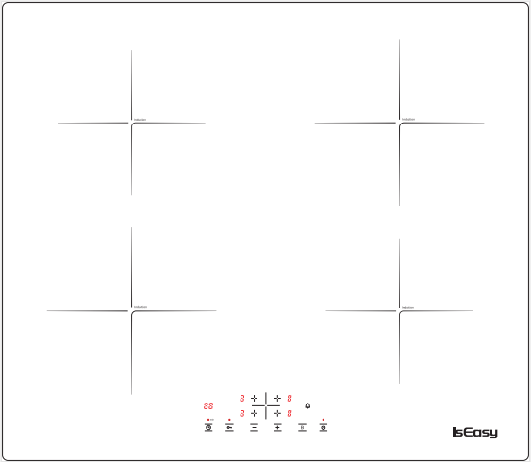

- Filo di fuoco marrone: alimentazione alla piastra superiore ed inferiore sul lato sinistro.
- Filo di fuoco nero: alimentazione alla piastra superiore ed inferiore sul lato destro.
- Pannello di controllo: Prendi l'alimentazione a 5 V dalla scheda di alimentazione in basso a destra.
Per quanto riguarda l'errore del problema di cablaggio (controlla quale dei seguenti è il tuo problema con il piano cottura):
- La piastra superiore ed inferiore sul lato sinistro riportano "E8" o non funzionano contemporaneamente. Controllare se il filo di fuoco marrone è in cattivo contatto. Se il cablaggio è allentato, ricollegarlo. Se confermi che il cablaggio è normale, contattaci per inviare le immagini della posizione del cablaggio e un video del guasto del piano cottura.

- Le piastre superiore ed inferiore sui lati sinistro e destro, di cui una riporta E8, potrebbero essere la scheda di potenza danneggiata. vi preghiamo di contattarci per inviare le foto della posizione del cablaggio e un video del guasto del piano.

Altri difetti correlati del piano a induzione
- E1 Errore: La bobina del filo è a circuito aperto. (Problema della scheda madre.)
- E2 Errore: L'NTC della sonda di superficie della stufa a filo è aperto o in corto. (Problema sulla scheda madre, la sonda di superficie della stufa NTC non è inserita nella sezione nera, oppure la sonda di superficie della stufa NTC è danneggiata.)

- E3 Errore: guasto ad alta tensione. (In primo luogo, assicurati che la tensione del circuito domestico sia 220 V-240 V. Se la tensione è corretta, potrebbe esserci un problema con la scheda madre.)
- E4 Errore: guasto a bassa tensione. (In primo luogo, assicurati che la tensione del circuito domestico sia 220 V-240 V. Se la tensione è corretta, potrebbe esserci un problema con la scheda madre.)
- E8 Errore: errore di comunicazione. (La scheda madre è danneggiata.)

E-mail del servizio clienti: service@iseasy.com
(Invia video e immagini pertinenti al nostro indirizzo e-mail e allega il numero dell'ordine Amazon. Dopo aver confermato il problema, ti forniremo sicuramente una soluzione soddisfacente.)

PRIMA DELL'USO
IMPORTANTE: Le zone di cottura non si accendono se le pentole non sono della giusta dimensione. Utilizzare esclusivamente pentole contrassegnate dal simbolo “SISTEMA DI INDUZIONE” (figura sotto). Posizionare la pentola sulla zona di cottura desiderata prima di accendere il piano cottura.

Pentole E Padelle ESISTENTI
Verifica con un magnete se la pentola è adatta al piano a induzione: pentole e padelle sono inadatte se non rilevabili magneticamente.
- Assicurati che le pentole abbiano il fondo liscio, altrimenti potrebbero graffiare il piano. Controllare i piatti.
- Non appoggiare mai pentole o padelle calde sulla superficie del pannello di controllo del piano cottura. Ciò potrebbe causare danni.
- Il diametro inferiore di pentole o padelle deve essere di almeno 10 cm.

ISTRUZIONI PER L'USO
PANORAMICA GENERALE

Per evitare danni permanenti al piano in vetroceramica, non utilizzare:
- Pentole con fondo non perfettamente piatto.
- Pentole in metallo con fondo smaltato.

DISPOSIZIONE DEL PANNELLO DI CONTROLLO

Accensione/spegnimento del piano cottura
Per accendere il piano cottura, premere il pulsante e i display delle zone di cottura si accendono.

Se entro 120 secondi dall'accensione non viene selezionata nessuna zona di riscaldamento, il piano si spegne automaticamente.

Accensione e regolazione del livello di cottura
Una volta acceso il piano e posizionata la pentola sulla zona di cottura prescelta, tasto corrispondente: il display visualizza il livello 0.Ogni zona di cottura ha vari livelli di potenza,regolare il livello di potenza premendo il tasto “+” o “-” .

Funzione booster
Dopo aver selezionato la zona di cottura desiderata, premendo il tasto B fino al livello massimo, La zona di cottura continuerà a lavorare alla massima velocità per 5 minuti.

Blocco bambini
Questa funzione blocca i comandi per evitare accensioni accidentali del piano. Per attivare la funzione di blocco bambini， accendere il piano cottura e tenere premuto il pulsante per tre secondi; il timer mostra Lo. Quindi il pannello di controllo è bloccato. Per disattivare il blocco del pannello comandi ripetere la procedura di attivazione. Il Lo si spegne e il piano si riattiva.
Timer
Con il timer è possibile impostare il tempo di cottura per un massimo di 99 minuti per tutte le zone di cottura.
Selezionare la zona di cottura da utilizzare con il timer, premere il pulsante con il simbolo dell'orologio quindi impostare il tempo di cottura desiderato premendo e,Dopo alcuni secondi, il timer inizia il conto alla rovescia.
Trascorso il tempo impostato, vengono emessi tre segnali acustici e il piano si spegne automaticamente.
Per disattivare il timer tenere premuto il pulsante con il simbolo dell'orologio per almeno 4 secondi.

Suono del timer spento

Se si desidera disattivare il suono del tempo, premere questo pulsante. Al termine del cronometraggio non verrà emesso alcun avviso.

Spegnimento automatico
Il piano cottura si spegnerà automaticamente se non hai impostato il tempo di cottura, hai dimenticato di spegnere il piano cottura e non hai utilizzato il piano cottura per due ore.

AVVERTENZE DEL PANNELLO DI CONTROLLO
Indicatore di calore residuo
- Il piano è dotato di un indicatore di calore residuo per ciascuna zona di cottura.
- Questi indicatori avvisano l'utente quando le zone di cottura sono ancora calde.
- Se il display mostra, la zona di cottura è ancora calda.

- Se la spia del calore residuo di una determinata zona di cottura è accesa, quella zona può essere utilizzata, ad esempio, per tenere in caldo una pietanza o per sciogliere il burro.
- Quando la zona di cottura si raffredda, il display si spegne.

Indicatore pentola errato o mancante
- Se stai utilizzando una pentola non adatta, non posizionata correttamente o non delle dimensioni corrette per il tuo piano a induzione, sul display comparirà la scritta “E0”, Se entro 120 secondi non viene rilevata nessuna pentola, il piano si spegne.

CLEANING
    - Non utilizzare pulitori a vapore.
    - Prima della pulizia assicurarsi che le zone di cottura siano spente e che l'indicatore di calore residuo (“H”) non sia visualizzato.
IMPORTANTE: Non utilizzare spugne abrasive o spugne abrasive. Il loro utilizzo potrebbe eventualmente rovinare il vetro.
- Dopo ogni utilizzo, pulire il piano (quando è freddo) per rimuovere eventuali depositi e macchie dovute ai residui di cibo.
- Lo zucchero o gli alimenti ad alto contenuto zuccherino danneggiano il piano e devono essere rimossi immediatamente.
- Sale, zucchero e sabbia potrebbero graffiare la superficie del vetro.
- Utilizzare un panno morbido, carta assorbente da cucina o un detergente specifico per piani cottura (seguire le istruzioni del produttore).

GUIDA ALLA RISOLUZIONE DEI PROBLEMI
- Leggere e seguire le istruzioni riportate nella sezione “Istruzioni per l'uso”.
- •Verificare che l'alimentazione elettrica non sia stata interrotta.
- •Asciugare bene il piano dopo averlo pulito.
- •Se, all'accensione del piano, sul display vengono visualizzati codici alfanumerici, consultare la tabella seguente per le istruzioni.
- Se non è possibile spegnere il piano dopo averlo utilizzato, scollegarlo dalla rete elettrica.

Codice di errore | Causa possibile | Remedy
E0 | No Pan o non ha rilevato il pan | Metti sulla padella
E2 | NTC corto o aperto | Chiamare il servizio post vendita e specificare il codice di errore
E3 | Alta tensione | Chiamare il servizio post vendita e specificare il codice di errore
E4 | Basso voltaggio | Chiamare il servizio post vendita e specificare il codice di errore

RUMORI PRODOTTI DAL PIANO COTTURA
- •I piani cottura a induzione possono emettere fischi o scoppiettii durante il normale funzionamento, questi infatti provengono dalle pentole e dalle padelle a causa delle caratteristiche dei fondi (ad esempio fondi formati da più strati di materiale, o fondi irregolari).
- •Questi rumori variano a seconda delle pentole e delle padelle utilizzate e della quantità di cibo che contengono e non sono indicativi di un difetto di alcun tipo.
- •Inoltre, il piano a induzione è dotato di un sistema di raffreddamento interno per il controllo della temperatura delle parti elettroniche; di conseguenza, durante il funzionamento e per alcuni minuti dopo lo spegnimento del piano, si avvertirà il rumore della ventola di raffreddamento.
- Ciò è perfettamente normale e anzi essenziale per il corretto funzionamento dell'apparecchio.

ASSISTENZA POST-VENDITA
Prima di contattare il Servizio Post Vendita:
1. Verifica se riesci a risolvere il problema da solo con l'aiuto della "Guida alla risoluzione dei problemi".
2. Spegnere e riaccendere l'apparecchio per verificare se il problema è stato eliminato.
Se il problema persiste dopo i controlli di cui sopra, contattare il Servizio Post Vendita più vicino.
Specificare sempre:
- una breve descrizione del guasto
- il tipo di prodotto e il modello esatto
- il tuo indirizzo completo
- il tuo numero di telefono
In caso di riparazioni, rivolgersi ad un Centro di Assistenza Tecnica autorizzato (per garantire l'utilizzo di ricambi originali e la corretta riparazione). I pezzi di ricambio sono disponibili.

Risparmio energetico
Per risultati ottimali, è consigliabile:
- Utilizzare pentole e padelle con larghezza del fondo uguale a quella della zona di cottura.
- Utilizzare solo pentole e padelle a fondo piatto.
- Quando possibile, tieni i coperchi delle pentole durante la cottura.
- Utilizzare una pentola a pressione per risparmiare ancora più energia e tempo.
- Posizionare la pentola al centro della zona di cottura segnata sul piano cottura.

Customer Support：
E-Mail: service@iseasy.com
Website: www.iseasy.com

